Foto | Articolo | Qty | EAN | Retail | TOT Retail
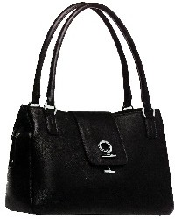 | LAM001 | 4 | 806891267061 | 315,00 € | 1.260,00 €
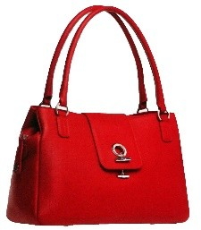 | LAM002 | 4 | '0806891267078 | 315,00 € | 1.260,00 €
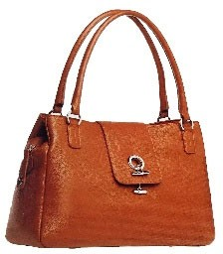 | LAM003 | 2 | '0806891267085 | 315,00 € | 630,00 €
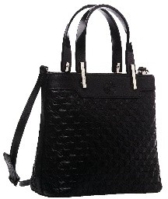 | LAM004 | 4 | '0806891267092 | 219,00 € | 876,00 €
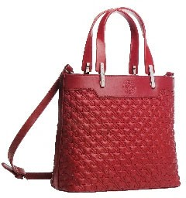 | LAM005 | 2 | '0806891267108 | 219,00 € | 438,00 €
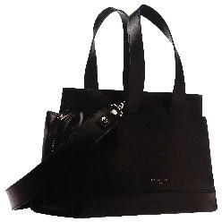 | LAM006 | 4 | '0806891267115 | 399,00 € | 1.596,00 €
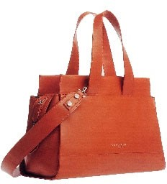 | LAM007 | 2 | '0806891267122 | 399,00 € | 798,00 €
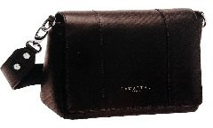 | LAM008 | 4 | '0806891267139 | 339,00 € | 1.356,00 €
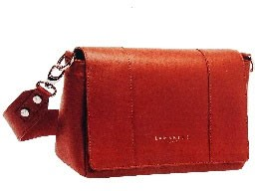 | LAM009 | 4 | '0806891267146 | 339,00 € | 1.356,00 €
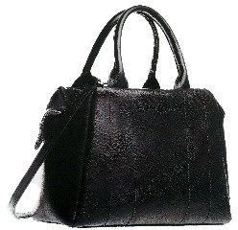 | LAM010 | 4 | '0806891267153 | 349,00 € | 1.396,00 €
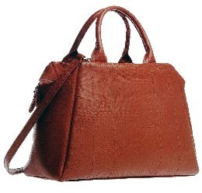 | LAM011 | 4 | 806891267160 | 349,00 € | 1.396,00 €
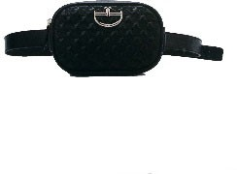 | LAM012 | 6 | '0806891267177 | 219,00 € | 1.314,00 €
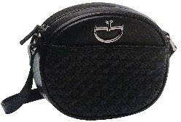 | LAM013 | 6 | '0806891267184 | 219,00 € | 1.314,00 €
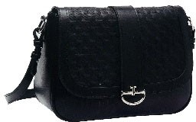 | LAM014 | 6 | '0806891267191 | 239,00 € | 1.434,00 €
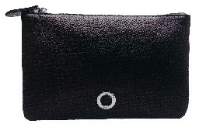 | LAM015 | 18 | '0806891267207 | 79,00 € | 1.422,00 €
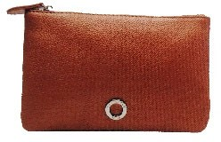 | LAM016 | 16 | '0806891267214 | 79,00 € | 1.264,00 €

Foto | Articolo | Qty | EAN | Retail | TOT Retail
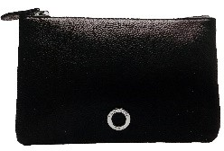 | LAM017 | 6 | '0806891267221 | 89,00 € | 534,00 €
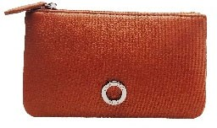 | LAM018 | 6 | '0806891267238 | 89,00 € | 534,00 €
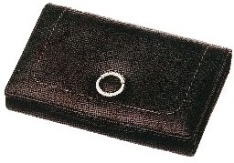 | LAM019 | 6 | '0806891267245 | 139,00 € | 834,00 €
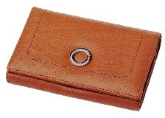 | LAM020 | 6 | '0806891267252 | 139,00 € | 834,00 €
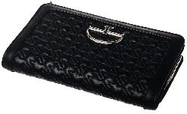 | LAM021 | 18 | '0806891267269 | 199,00 € | 3.582,00 €
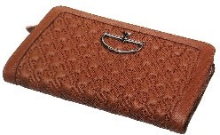 | LAM022 | 36 | '0806891267276 | 199,00 € | 7.164,00 €
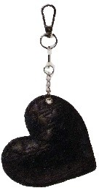 | LAM023 | 34 | '0806891267283 | 49,00 € | 1.666,00 €
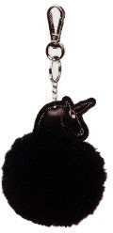 | LAM024 | 15 | '0806891267290 | 69,00 € | 1.035,00 €
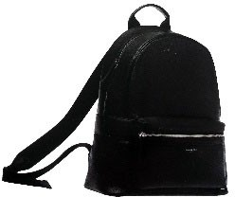 | LAM025 | 4 | '0806891267306 | 365,00 € | 1.460,00 €
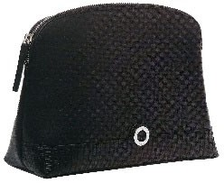 | LAM026 | 36 | '0806891267313 | 149,00 € | 5.364,00 €
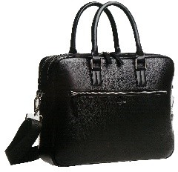 | LAM027 | 11 | '0806891267320 | 359,00 € | 3.949,00 €
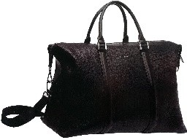 | LAM028 | 4 | '0806891267337 | 469,00 € | 1.876,00 €
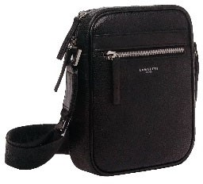 | LAM029 | 6 | '0806891267344 | 159,00 € | 954,00 €
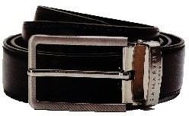 | LAM030 | 32 | '0806891267351 | 89,00 € | 2.848,00 €
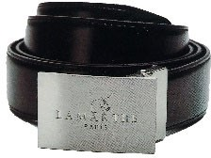 | LAM031 | 18 | '0806891267368 | 89,00 € | 1.602,00 €
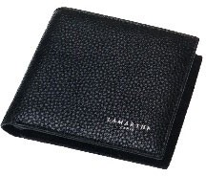 | LAM032 | 3 | '0806891267375 | 99,00 € | 297,00 €

Foto | Articolo | Qty | EAN | Retail | TOT Retail
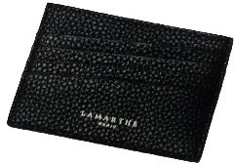 | LAM033 | 34 | '0806891267382 | 69,00 € | 2.346,00 €
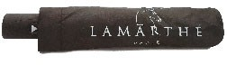 | LAM034 | 36 | '0806891267399 | 39,00 € | 1.404,00 €
TOTALE |  | 401 |  | 143,12 € | 57.393,00 €

